Embedded System Design of a Hybrid Navigation Robot
Using IR and Ultrasonic Sensors with Arduino

Basudeb Kundu
Department of Computer Science & Engineering, AIUB
Email: 23-50856-1@student.aiub.edu
Indronill Dutta Nill
Department of Computer Science & Engineering, AIUB
Email: 23-50974-1@student.aiub.edu
Debashis Kumar Das
Department of Computer Science & Engineering, AIUB
Email: 23-50953-1@student.aiub.edu
Nafiur Rahman Nirob Department of Computer Science & Engineering, AIUB
Email: 23-50991-1@student.aiub.edu

Prohlad Chandra Das
Department of Computer Science & Engineering, AIUB
Email: 23-50922-1@student.aiub.edu

Abstract— This robotic vehicle can automatically chase and drive on paths without outside help. Built around the popular Arduino UNO microcontroller, it adds IR sensors for line spotting and ultrasonic sensors attached to a servo motor for obstacle avoiding. Today, merging robots and making things happen without humans into daily life is a target reached. This is a motivating force for students and hobbyists looking to learn the fundamentals of robotics and embedded systems, as this robot can be easily built and offers a practical means to explore DIY robotics. Upon accomplishing this goal, students and educators will be motivated to engage in different challenges revolving around the emerging fields of automation.
Index Terms—Arduino Uno, Obstacle Avoidance, Line Following Robot, IR Sensor, Ultrasonic Sensor, Servo Motor, Motor Driver.

Introduction
Robotics has attracted the attention of students and inventors, from basic mobilized apparatus to intelligent robots. Increasing demand for home and industrial automation — even at toy scale — makes autonomous vehicles great educational vehicles. In this project, an attempt was made to design a car that could autonomously follow a marked path line (generally a black line) and intelligently respond to obstacles with the aid of ultrasonic sensors. Such a robot could be used for warehousing or indoor navigation; it could also serve as an educational prototype illustrating the interplay between sensors and microcontrollers in animating machines.

II. METHODOLOGY
This section describes the systematic approach taken for design, build, and code the obstacle avoiding and line following robotic car. The method can be loosely split into four main steps: choose parts and plan costs, create circuit and setup, develop algorithm, and test and calibrate.

Component Choose & Cost Plan
The main aim was to create a cheap, self-running robot base using easy-to-get electronic parts. Every part was picked on its ability to work well, fit with Arduino Uno, and be good for line following and obstacle sensing uses.

Component | Quantity | Unit Cost (tk) | Total Cost (tk)
Arduino Uno R3 Microcontroller | 1 | 995 | 995
IR Obstacle Detection Sensor Module | 2 | 70 | 140
HC-SR04 Ultrasonic Sensor | 1 | 86 | 86
SG90 Servo Motor (180° rotation) | 1 | 135 | 135
L298N Dual H-Bridge Motor Driver | 1 | 180 | 180
6V 100 RPM DC Gear BO Motor | 4 | 85 | 340
Yellow Plastic Mag Wheel (Soft) | 4 (set) | — | 300
Small Breadboard | 1 | 50 | 50
Rechargeable Battery (6V) | 2 | 80 | 160
Total Cost |  |  | 2,386 tk
This budget-friendly setup allowed us to build a versatile robotic platform without compromising on basic functionality.
Subsystem 1: Line Following System:
The Line Following System Infrared (IR) sensors were installed on the front lower side of the robot. These sensors output a digital value (LOW for black surface, HIGH for white). They were placed at an equal distance from the center Left-Right can be detected along with the line in which it is aligned.
Subsystem 2: Obstacle Avoidance System:
An ultrasonic distance sensor of the HC-SR04 model was mounted on a servo motor of the SG90 type to enable dynamic scanning of the environment. The servo was instructed to rotate the ultrasonic sensor between -45 degrees and +45 degrees to take distance readings from the left and right sides. The Arduino uses pulseIn() to measure time delay between transmitted and received pulses; it then calculates how far obstacles are.
Subsystem 3: Motor Control and Power Management:
Four BO gear motors were coupled to the L298N motor driver. The L298N was connected to Arduino via digital PWM pins for bidirectional movement and speed control. Dual 6V battery pack powered the motors. Arduino was powered either through USB or external 9V input.

Testing and Calibration
Iterations of testing were carried out on different surface conditions and lighting environments.
IR Sensor Calibration:
Calibrated the sensors by adjusting the threshold values to reduce false positives from ambient light.
Ultrasonic Sensor Accuracy:
Measured the distance with a ruler. Tuned delay and trigger pulse for stable measurement available for further improvement.
Motor Testing:
Each motor was tested individually to make sure normal speed and direction. Small adjustments were made with PWM values to fix hardware differences.
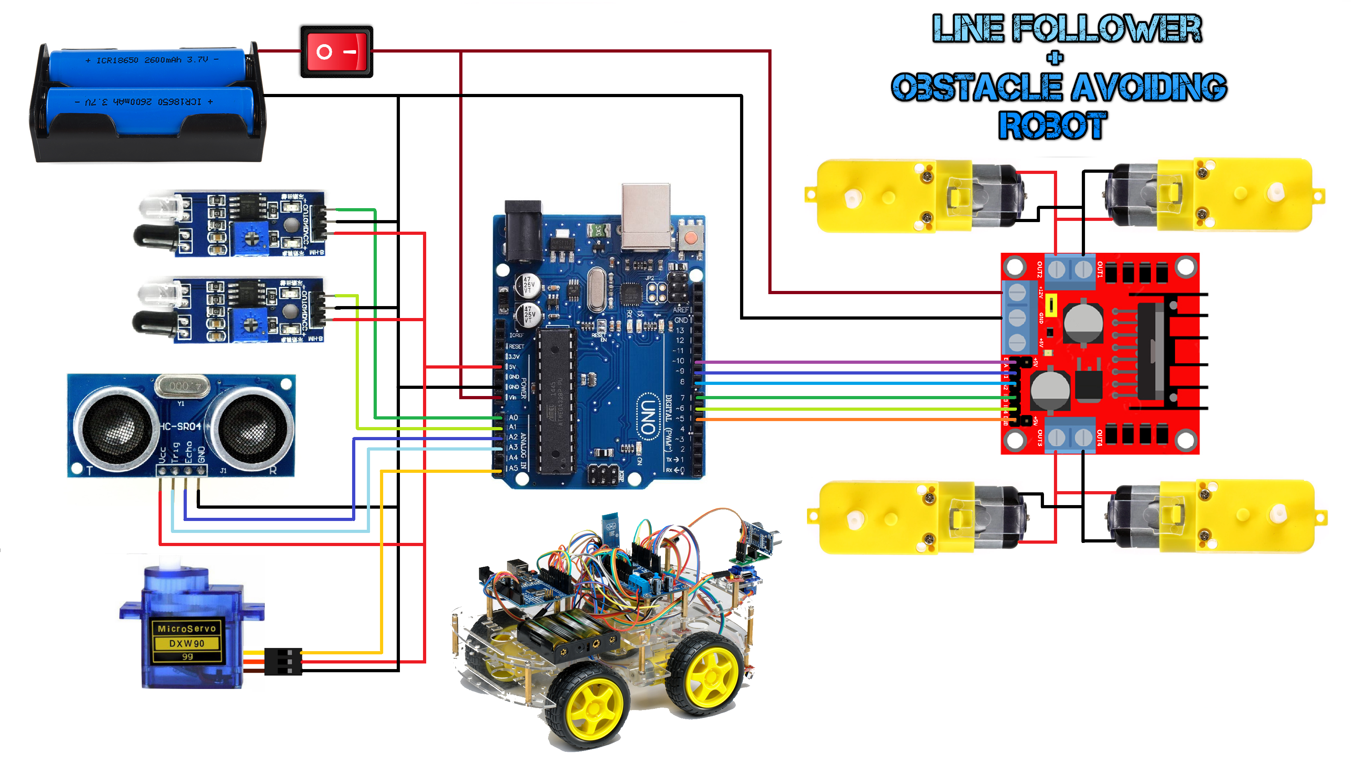
Fig1: Circuit diagram of connection

Software Architecture and Control Algorithm

The embedded logic has been realized in C++ with the help of Arduino IDE. The software exhibits a structured modular design and the main functions are as follows:

1.Initialization:

- Sensor, motor, and servo pin configuration

- Calibration routines for IR sensors

- Setting the servo to default (center) position

2.Line Following Algorithm:

- The state of both IR sensors is read continuously.

- A conditional logic loop is implemented whereby:

- If both the sensors detect white → move forward.

- If the left sensor detects black → turn right.

- If right sensor sees black → turn left.

- If both sensors see black → stop (end of line or intersection).

3.Obstacle Detection Routine

- It keeps on looking at the distance from the HC-SR04 sensor.

- If it sees something within 20 cm:

- Robot stops.

- Servo turns sensor to the left and right.

- Distance comparison is made.

- Robot turns in the direction with more free space and starts moving again.

4.Motor Control Logic

- PWM control for smooth acceleration and turning.

- L298N driver logic handles forward, reverse, and stop commands for all four wheels.

The robot was tested in a looped path with many turns and put near cardboard and plastic objects to simulate obstacle hits. Real-time debugging was done using Serial Monitor.

RESULTS AND DISCUSSION
After putting together all the parts and uploading the control program to the Arduino Uno, the robotic car was tried out in a controlled indoor setting using black tape to show the way and small unmoving items to show obstacles. During line-following tests, the robot could watch both straight and curved paths consistently. Small speed changes made it better at turning without leaving the line, making sure it stayed better aligned with the path.
As regards the avoidance of obstacles, the ultrasonic sensor HC-SR04 was able to pick up proximate objects within the set threshold quite effectively. The implementation of a servo motor to swing the sensor gave it the ability to look left and right, thereby giving the robot an opportunity to assess its environment before it chooses a clear path. The switch between the modes of obstacle avoidance and line following was seamless and in any case giving priority to safety as it comes to a halt first before making any directional change.
There were a number of issues that cropped up in the course of testing. At times, the IR sensors proved to be overly sensitive in conditions of strong ambient lighting and gave spurious readings. This was taken care of by somewhat shielding the sensors so as to cut down on the interference from the light. Also, the speeds at which the motors moved needed to be carefully calibrated because going too fast sometimes made the robot overshoot the track. Instability in power on prolonged usage was also noted and solved by implementing a two-battery system to give more stable voltage supply.
The Arduino code was made better by changing the delay values and sensor thresholds. A short break was added before changing modes to stop wild movement, which led to more controlled and dependable navigation. In general, the robotic car showed good ability in both line-following and obstacle avoidance jobs, highlighting how effective a well-coordinated low-cost system can be when built with Arduino.

CONCLUSION
In this project, we have built a simple and effective autonomous robot which can do both line following as well as obstacle avoidance. Basic sensors and motors have been demonstrated how they can be combined into a working robotic system with the addition of reliable IR and ultrasonic sensors plus the flexibility of Arduino programming. This project acts as a very good introductory experience in embedded systems and robotics for students as well as beginners. With further enhancement, this little robot could be much more capable and smarter, maybe through Bluetooth control or even PID-based line following.

References

[[1] Arduino, Arduino Uno Rev3 Technical Specifications, Arduino Documentation, 2015.

[2] J. W. Valvano, Embedded Systems: Introduction to the ARM Cortex-M Microcontrollers, 5th ed. Boston, MA, USA: CreateSpace, 2015, pp. 112–145.

[3] HC-SR04, Ultrasonic Sensor Technical Datasheet, Elecfreaks Co., Ltd., 2017, pp. 2–6.

[4] Tower Pro, SG90 Micro Servo Motor Specifications Manual, Tower Pro Co., Ltd., 2016, pp. 1–4.

[5] STMicroelectronics, L298N Dual H-Bridge Motor Driver Datasheet, Rev. 2, 2015, pp. 3–9.

[6] K. Sharma and R. Singh, "Design and implementation of IR sensor based line follower robot," International Journal of Advanced Research in Electronics and Communication Engineering (IJARECE), vol. 5, no. 4, pp. 998–1002, Apr. 2016.

[7] A. Malik and M. H. Rashid, "Design and Implementation of a Line Follower Robot using Arduino Microcontroller," International Journal of Scientific & Engineering Research, vol. 10, no. 5, pp. 1225–1229, May 2019.

[8] A. R. Al-Ali and K. Al-Mashaqbeh, "An Educational Autonomous Car Based on Arduino and Sensors," in Proc. IEEE Global Engineering Education Conference (EDUCON), pp. 140–145, Apr. 2021.

[9] S. Patel and D. Sharma, "Development of Obstacle Avoiding Robot using Ultrasonic Sensor," International Journal of Engineering Research and Applications, vol. 7, no. 2, pp. 45–48, Feb. 2017.

